# **Data Kelompok:**

* Adistia Ramadhani 2113191084
* Alam Nurzaman 2113191108
* Dara Atria Ferilandini 2113191098
* Isep Lutpi Nur 2113191079

# **Contoh Kasus:**

Penyederhanaan query untuk pengadaan dan penjualan obat serta validasi nama dalam penambahan jenis, kategori dan obat pada database Apotik.

# **Database dan struktur table:**

1. Entity Relationship Diagram Database

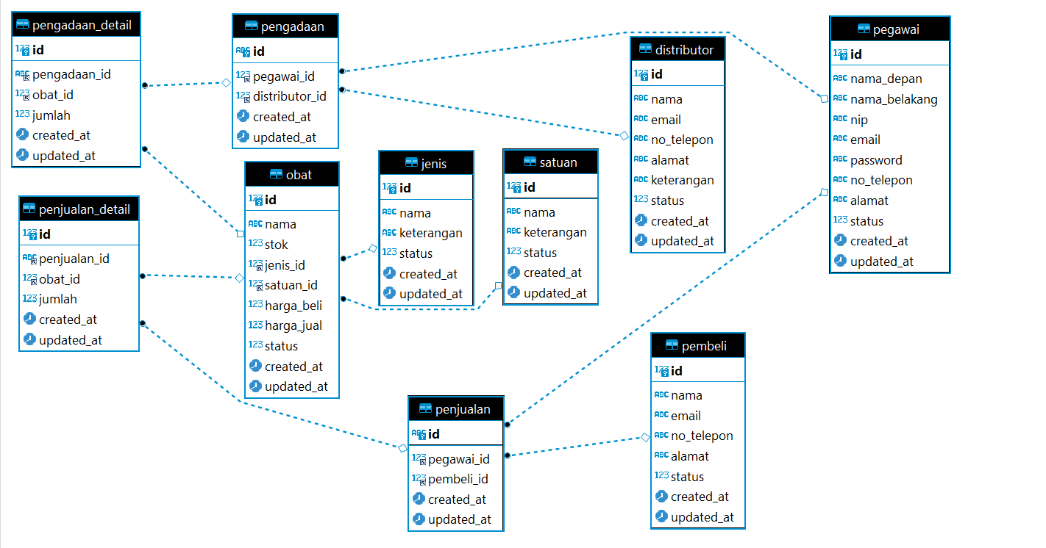

1. Procedure
2. **Insert Jenis (Rollback)**
3. Pengertian

Procedure ini berfungsi untuk mem-validasi nama jenis agar nama jenis tidak ada yang lebih dari satu. Cara kerjanya yaitu dengan cara mengambil data jenis dimana namanya sama dengan yang akan ditambahkan, jika dapat lebih dari nol atau sudah ada maka dibawah nya ada decision yaitu jika terdapat nama yang sama maka akan di rollback, tetapi jika tidak maka akan di commit.

1. Sintaks

DELIMITER $$

CREATE PROCEDURE `insertJenis`(

  IN `nama` VARCHAR(255),

  IN `keterangan` TEXT,

  IN `status` ENUM('1','0')

)

BEGIN

  DECLARE hitungJenis INT(11);

    DECLARE result VARCHAR(255);

    SET hitungJenis = (SELECT count(*) FROM jenis WHERE jenis.nama = nama);

    START TRANSACTION;

  INSERT INTO jenis

    VALUES(null, nama, keterangan, status,

           CURRENT_TIMESTAMP(),

           CURRENT_TIMESTAMP());

    IF(hitungJenis > 0) THEN

      ROLLBACK;

      SET result = 'Nama Jenis Sudah Digunakan';

    ELSE

      COMMIT;

      SET result = 'Jenis berhasil disimpan';

    END IF;

    SELECT result;

END$$

DELIMITER ;

1. **Pengadaan Header**
2. Pengertian

Pengadaan header ini berfungsi untuk header tabel pengadaan_detail. Pengadaan header akan menambahkan data ke tabel pengadaan.

1. Sintaks

DELIMITER $$

CREATE PROCEDURE `insertPengadaanHeader`(

  IN `id` VARCHAR(255),

  IN `pegawai_id` INT(11),

  IN `distributor_id` INT(11)

)

BEGIN

    INSERT INTO pengadaan VALUES(

        id,

      pegawai_id,

        distributor_id,

        CURRENT_TIMESTAMP(),

        CURRENT_TIMESTAMP()

    );

END$$

DELIMITER ;

1. **Pengadaan Body**
2. Pengertian

Procediure ini berfungi untuk pengadaan obat. Dalam procedure ini terdapat 2 query yaitu update stok obat (menambahkan stok obat) dan insert pengadaan detail. Prosedur ini juga berfungsi untuk menyederhanakan 2 query update dan insert.

1. Sintaks

DELIMITER $$

CREATE PROCEDURE `insertPengadaanBody`(

  IN `pengadaan_id` VARCHAR(255),

  IN `obat_id` INT(11),

  IN `jumlah` INT(11)

)

BEGIN

  UPDATE obat SET stok = (stok + jumlah) WHERE id = obat_id;

  INSERT INTO pengadaan_detail VALUES (

    null, pengadaan_id, obat_id, jumlah,

      CURRENT_TIMESTAMP(),

      CURRENT_TIMESTAMP()

  );

END$$

DELIMITER ;

1. **Pengadaan View**
2. Pengertian

Prosedure ini berfungsi untuk melihat perubahan dari query pengadaan sebelumnya.

1. Sintaks

DELIMITER $$

CREATE PROCEDURE `insertPengadaanView`(

  in pengadaan_id varchar(255)

)

BEGIN

  SELECT

    b.id,

    obat.nama as obat_nama,

    (obat.stok - a.jumlah) as stok_asal,

    a.jumlah as tambah_jumlah,

    obat.stok as stok_sekarang,

    concat(pegawai.nama_depan, ' ', pegawai.nama_belakang) as pegawai_nama,

    distributor.nama as distributor_nama

  FROM

    pengadaan_detail as a

  JOIN

    pengadaan as b ON a.pengadaan_id = b.id

  JOIN

    obat ON a.obat_id = obat.id

  JOIN

    pegawai ON b.pegawai_id = pegawai.id

  JOIN

    distributor ON b.distributor_id = distributor.id

  WHERE

    a.pengadaan_id = pengadaan_id;

END$$

DELIMITER ;

1. **Penjualan Header**
2. Pengertian

Penjualan header ini berfungsi untuk header tabel penjualan_detail. Penjualan header akan menambahkan data ke tabel pengadaan.

1. Sintaks

DELIMITER $$

CREATE PROCEDURE `insertPenjualanHeader`(

  in id varchar(255),

  in pegawai_id int(11),

  in pembeli_id int(11)

)

BEGIN

    INSERT INTO penjualan VALUES(

        id,

      pegawai_id,

        pembeli_id,

        CURRENT_TIMESTAMP(),

        CURRENT_TIMESTAMP()

    );

END$$

DELIMITER ;

1. **Penjualan Body**
2. Pengertian

Procedure ini berfungi untuk penjuaalan obat. Dalam procedure ini terdapat 2 query yaitu update stok obat (Mengurangi stok obat) dan insert penjualan detail. Prosedur ini juga berfungsi untuk menyederhanakan 2 query update dan insert.

1. Sintaks

DELIMITER $$

CREATE PROCEDURE `insertPenjualanBody`(

  IN penjualan_id VARCHAR(255),

  IN obat_id INT(11),

  IN jumlah INT(11)

)

BEGIN

  UPDATE obat SET stok = (stok - jumlah) WHERE id = obat_id;

  INSERT INTO penjualan_detail VALUES (

      null, penjualan_id, obat_id, jumlah,

      CURRENT_TIMESTAMP(), CURRENT_TIMESTAMP()

    );

END$$

DELIMITER

1. **Penjualan View**
2. Pengertian

Prosedure ini berfungsi untuk melihat perubahan dari query pengadaan sebelumnya.

1. Sintaks

DELIMITER $$

CREATE PROCEDURE `insertPenjualanView`(

  IN penjualan_id VARCHAR(255)

)

BEGIN

  SELECT

    b.id,

      obat.nama as obat_nama,

      (obat.stok + a.jumlah) as stok_asal,

      a.jumlah as kurang_jumlah,

      obat.stok as stok_sekarang,

      concat(pegawai.nama_depan, ' ', pegawai.nama_belakang) as pegawai_nama,

      pembeli.nama as pembeli_nama

  FROM

    penjualan_detail as a

  JOIN

    penjualan as b ON a.penjualan_id = b.id

  JOIN

    obat ON a.obat_id = obat.id

  JOIN

    pegawai ON b.pegawai_id = pegawai.id

  LEFT JOIN

    pembeli ON b.pembeli_id = pembeli.id

  WHERE

    a.penjualan_id = penjualan_id;

END$$

DELIMITER ;

1. Import

-- phpMyAdmin SQL Dump

-- version 5.1.1

-- https://www.phpmyadmin.net/

--

-- Host: 127.0.0.1:3306

-- Generation Time: Dec 10, 2021 at 06:26 AM

-- Server version: 10.4.20-MariaDB

-- PHP Version: 7.4.21

SET SQL_MODE = "NO_AUTO_VALUE_ON_ZERO";

START TRANSACTION;

SET time_zone = "+00:00";

/*!40101 SET @OLD_CHARACTER_SET_CLIENT=@@CHARACTER_SET_CLIENT */;

/*!40101 SET @OLD_CHARACTER_SET_RESULTS=@@CHARACTER_SET_RESULTS */;

/*!40101 SET @OLD_COLLATION_CONNECTION=@@COLLATION_CONNECTION */;

/*!40101 SET NAMES utf8mb4 */;

--

-- Database: `apotik`

--

DELIMITER $$

--

-- Procedures

--

CREATE DEFINER=`root`@`localhost` PROCEDURE `getObat` ()  BEGIN

  select * from obat;

END$$

CREATE DEFINER=`root`@`localhost` PROCEDURE `insertJenis` (IN `nama` VARCHAR(255), IN `keterangan` TEXT, IN `status` ENUM('1','0'))  BEGIN

  DECLARE hitungJenis INT(11);

    DECLARE result VARCHAR(255);

    SET hitungJenis = (SELECT count(*) FROM jenis WHERE jenis.nama = nama);

    START TRANSACTION;

  INSERT INTO jenis

    VALUES(null, nama, keterangan, status,

           CURRENT_TIMESTAMP(),

           CURRENT_TIMESTAMP());

    IF(hitungJenis > 0) THEN

      ROLLBACK;

      SET result = 'Nama Jenis Sudah Digunakan';

    ELSE

      COMMIT;

      SET result = 'Jenis berhasil disimpan';

    END IF;

    SELECT result;

END$$

CREATE DEFINER=`root`@`localhost` PROCEDURE `insertPengadaanBody` (IN `pengadaan_id` VARCHAR(255), IN `obat_id` INT(11), IN `jumlah` INT(11))  BEGIN

  UPDATE obat SET stok = (stok + jumlah) WHERE id = obat_id;

    INSERT INTO pengadaan_detail VALUES (

      null, pengadaan_id, obat_id, jumlah,

        CURRENT_TIMESTAMP(),

        CURRENT_TIMESTAMP()

    );

END$$

CREATE DEFINER=`root`@`localhost` PROCEDURE `insertPengadaanHeader` (IN `id` VARCHAR(255), IN `pegawai_id` INT(11), IN `distributor_id` INT(11))  BEGIN

    INSERT INTO pengadaan VALUES(

        id,

      pegawai_id,

        distributor_id,

        CURRENT_TIMESTAMP(),

        CURRENT_TIMESTAMP()

    );

END$$

CREATE DEFINER=`root`@`localhost` PROCEDURE `insertPengadaanView` (IN `pengadaan_id` VARCHAR(255))  BEGIN

SELECT

  b.id,

    obat.nama as obat_nama,

    (obat.stok - a.jumlah) as stok_asal,

    a.jumlah as tambah_jumlah,

    obat.stok as stok_sekarang,

    concat(pegawai.nama_depan, ' ', pegawai.nama_belakang) as pegawai_nama,

    distributor.nama as distributor_nama

FROM

  pengadaan_detail as a

JOIN

  pengadaan as b ON a.pengadaan_id = b.id

JOIN

  obat ON a.obat_id = obat.id

JOIN

  pegawai ON b.pegawai_id = pegawai.id

JOIN

  distributor ON b.distributor_id = distributor.id

WHERE

  a.pengadaan_id = pengadaan_id;

END$$

CREATE DEFINER=`root`@`localhost` PROCEDURE `insertPenjualanBody` (IN `penjualan_id` VARCHAR(255), IN `obat_id` INT(11), IN `jumlah` INT(11))  BEGIN

  UPDATE obat SET stok = (stok - jumlah) WHERE id = obat_id;

  INSERT INTO penjualan_detail VALUES (

      null, penjualan_id, obat_id, jumlah,

      CURRENT_TIMESTAMP(),

      CURRENT_TIMESTAMP()

    );

END$$

CREATE DEFINER=`root`@`localhost` PROCEDURE `insertPenjualanHeader` (IN `id` VARCHAR(255), IN `pegawai_id` INT(11), IN `pembeli_id` INT(11))  BEGIN

    INSERT INTO penjualan VALUES(

        id,

      pegawai_id,

        pembeli_id,

        CURRENT_TIMESTAMP(),

        CURRENT_TIMESTAMP()

    );

END$$

CREATE DEFINER=`root`@`localhost` PROCEDURE `insertPenjualanView` (IN `penjualan_id` VARCHAR(255))  BEGIN

  SELECT

    b.id,

      obat.nama as obat_nama,

      (obat.stok + a.jumlah) as stok_asal,

      a.jumlah as kurang_jumlah,

      obat.stok as stok_sekarang,

      concat(pegawai.nama_depan, ' ', pegawai.nama_belakang) as pegawai_nama,

      pembeli.nama as pembeli_nama

  FROM

    penjualan_detail as a

  JOIN

    penjualan as b ON a.penjualan_id = b.id

  JOIN

    obat ON a.obat_id = obat.id

  JOIN

    pegawai ON b.pegawai_id = pegawai.id

  LEFT JOIN

    pembeli ON b.pembeli_id = pembeli.id

  WHERE

    a.penjualan_id = penjualan_id;

END$$

CREATE DEFINER=`root`@`localhost` PROCEDURE `log` (`msg` VARCHAR(255))  BEGIN

  select concat('** ', msg) AS '** DEBUG:';

END$$

DELIMITER ;

-- --------------------------------------------------------

--

-- Table structure for table `distributor`

--

CREATE TABLE `distributor` (

  `id` int(11) NOT NULL,

  `nama` varchar(255) DEFAULT NULL,

  `email` varchar(255) DEFAULT NULL,

  `no_telepon` varchar(255) DEFAULT NULL,

  `alamat` text DEFAULT NULL,

  `keterangan` text DEFAULT NULL,

  `status` int(11) DEFAULT NULL COMMENT '0 Tidak Aktif | 1 Aktif',

  `created_at` datetime NOT NULL DEFAULT current_timestamp(),

  `updated_at` datetime NOT NULL DEFAULT current_timestamp() ON UPDATE current_timestamp()

) ENGINE=InnoDB DEFAULT CHARSET=utf8mb4;

--

-- Dumping data for table `distributor`

--

INSERT INTO `distributor` (`id`, `nama`, `email`, `no_telepon`, `alamat`, `keterangan`, `status`, `created_at`, `updated_at`) VALUES

(1, 'Pt Kimia farma', 'kimiafarma@gmail.com', '085798132505', 'Bandung', 'Dumy', 1, '2021-10-07 12:28:40', '2021-10-07 12:28:40'),

(2, 'Pt obat sakti', 'sakti', '123', '123', 'ket', 1, '2021-10-07 12:28:40', '2021-10-07 12:28:40');

-- --------------------------------------------------------

--

-- Table structure for table `jenis`

--

CREATE TABLE `jenis` (

  `id` int(11) NOT NULL,

  `nama` varchar(255) DEFAULT NULL,

  `keterangan` text DEFAULT NULL,

  `status` int(11) DEFAULT NULL COMMENT '0 Tidak Aktif | 1 Aktif',

  `created_at` datetime NOT NULL DEFAULT current_timestamp(),

  `updated_at` datetime NOT NULL DEFAULT current_timestamp() ON UPDATE current_timestamp()

) ENGINE=InnoDB DEFAULT CHARSET=utf8mb4;

--

-- Dumping data for table `jenis`

--

INSERT INTO `jenis` (`id`, `nama`, `keterangan`, `status`, `created_at`, `updated_at`) VALUES

(1, 'Cair', 'ket', 1, '2021-10-07 12:31:45', '2021-10-07 12:31:45'),

(2, 'Tablet', 'ket', 1, '2021-10-07 12:31:45', '2021-10-07 12:31:45'),

(3, 'Kapsul', 'ket', 1, '2021-10-07 12:31:45', '2021-10-07 12:31:45'),

(4, 'Pill', 'ket', 1, '2021-10-07 12:31:45', '2021-10-07 12:31:45'),

(5, 'Serbuk', 'ket', 1, '2021-10-07 12:31:45', '2021-10-07 12:31:45'),

(6, 'Salep', 'ket', 1, '2021-10-07 12:31:45', '2021-10-07 12:31:45'),

(7, 'Tetes', 'ket', 1, '2021-10-07 12:31:45', '2021-10-07 12:31:45');

-- --------------------------------------------------------

--

-- Table structure for table `obat`

--

CREATE TABLE `obat` (

  `id` int(11) NOT NULL,

  `nama` varchar(255) DEFAULT NULL,

  `stok` int(11) DEFAULT NULL,

  `jenis_id` int(11) DEFAULT NULL,

  `satuan_id` int(11) DEFAULT NULL,

  `harga_beli` bigint(20) DEFAULT NULL,

  `harga_jual` bigint(20) DEFAULT NULL,

  `status` int(11) DEFAULT NULL COMMENT '0 Tidak Aktif | 1 Aktif',

  `created_at` datetime NOT NULL DEFAULT current_timestamp(),

  `updated_at` datetime NOT NULL DEFAULT current_timestamp() ON UPDATE current_timestamp()

) ENGINE=InnoDB DEFAULT CHARSET=utf8mb4;

--

-- Dumping data for table `obat`

--

INSERT INTO `obat` (`id`, `nama`, `stok`, `jenis_id`, `satuan_id`, `harga_beli`, `harga_jual`, `status`, `created_at`, `updated_at`) VALUES

(1, 'Paracetamol', 45, 2, 2, 2500, 5000, 1, '2021-10-07 12:34:48', '2021-12-10 11:01:54'),

(2, 'Kataflam', 0, 2, 2, 10000, 15000, 1, '2021-10-07 12:41:44', '2021-10-07 12:41:44'),

(3, 'Antimo', 26, 1, 2, 5000, 7500, 1, '2021-10-07 12:41:44', '2021-12-10 11:01:54'),

(4, 'Tramadol', 5, 1, 1, 10000, 15000, 1, '2021-10-07 12:49:07', '2021-12-10 11:01:54'),

(5, 'PIROXICAM', 5, 2, 1, 100000, 150000, 1, '2021-10-09 13:38:36', '2021-12-10 11:01:54'),

(6, 'Hydrocorti', 1, 6, 2, 10000, 13000, 1, '2021-10-09 13:38:36', '2021-10-09 16:38:20'),

(7, 'Acyclovir Cream', 1, 6, 2, 7000, 10000, 1, '2021-10-09 13:40:26', '2021-10-09 16:38:17'),

(8, 'Ethambutol', 2, 2, 2, 20000, 21000, 1, '2021-10-09 13:40:26', '2021-10-09 16:38:13'),

(9, 'Promag', 5, 2, 1, 13000, 15000, 1, '2021-10-09 13:43:41', '2021-10-09 16:38:10'),

(10, 'Nebacetin', 4, 5, 2, 20000, 25000, 1, '2021-10-09 13:43:41', '2021-10-09 16:38:05');

-- --------------------------------------------------------

--

-- Table structure for table `pegawai`

--

CREATE TABLE `pegawai` (

  `id` int(11) NOT NULL,

  `nama_depan` varchar(255) DEFAULT NULL,

  `nama_belakang` varchar(255) DEFAULT NULL,

  `nip` varchar(255) DEFAULT NULL,

  `email` varchar(255) DEFAULT NULL,

  `password` varchar(255) DEFAULT NULL,

  `no_telepon` varchar(255) DEFAULT NULL,

  `alamat` text DEFAULT NULL,

  `status` int(11) DEFAULT NULL COMMENT '0 Tidak Aktif | 1 Aktif',

  `created_at` datetime NOT NULL DEFAULT current_timestamp(),

  `updated_at` datetime NOT NULL DEFAULT current_timestamp() ON UPDATE current_timestamp()

) ENGINE=InnoDB DEFAULT CHARSET=utf8mb4;

--

-- Dumping data for table `pegawai`

--

INSERT INTO `pegawai` (`id`, `nama_depan`, `nama_belakang`, `nip`, `email`, `password`, `no_telepon`, `alamat`, `status`, `created_at`, `updated_at`) VALUES

(1, 'Isep Lutpi', 'Nur', '2113191234', 'iseplutfinur@gmail.com', 'isep1234', '0888134689793', 'Sekeloa, Bandung', 1, '2021-10-09 13:49:29', '2021-10-09 13:59:29'),

(2, 'Adistia ', 'Ramadhani', '2113174658', 'adistiaramadhani@gmail.com', 'adistia123', '089364765685', 'Antapani,Bandung', 1, '2021-10-09 13:49:29', '2021-10-09 13:49:29'),

(3, 'Alam', 'Nurzaman', '21131746568', 'alamnurzaman@gmail.com', 'alam1234', '088834561239', 'Ciumbuleuit, Bandung', 1, '2021-10-09 13:55:47', '2021-10-09 13:55:47'),

(4, 'Dara Atria', 'Ferliandini', '2113191098', 'daraatriaferliandini@gmail.com', 'dara1234', '0889391328', 'Cikutra Barat, Bandung', 1, '2021-10-09 13:55:47', '2021-10-09 13:55:47');

-- --------------------------------------------------------

--

-- Table structure for table `pembeli`

--

CREATE TABLE `pembeli` (

  `id` int(11) NOT NULL,

  `nama` varchar(255) DEFAULT NULL,

  `email` varchar(255) DEFAULT NULL,

  `no_telepon` varchar(255) DEFAULT NULL,

  `alamat` text DEFAULT NULL,

  `status` int(11) DEFAULT NULL COMMENT '0 Tidak Aktif | 1 Aktif',

  `created_at` datetime NOT NULL DEFAULT current_timestamp(),

  `updated_at` datetime NOT NULL DEFAULT current_timestamp() ON UPDATE current_timestamp()

) ENGINE=InnoDB DEFAULT CHARSET=utf8mb4;

--

-- Dumping data for table `pembeli`

--

INSERT INTO `pembeli` (`id`, `nama`, `email`, `no_telepon`, `alamat`, `status`, `created_at`, `updated_at`) VALUES

(1, 'Zayn Malik', 'zaynmalik@gmail.com', '08889391329', 'Bojongkoneng', 1, '2021-10-09 13:58:45', '2021-10-09 13:58:45'),

(2, 'Harry Styles', 'harrys@gmail.com', '088854328586', 'Cibangkong', 1, '2021-10-09 13:58:45', '2021-10-09 13:58:45'),

(3, 'Gigi Hadid', 'gigihadid@gmail.com', '088938656877', 'Sadang Serang', 1, '2021-10-09 14:01:49', '2021-10-09 14:01:49'),

(4, 'Kendall Jenner', 'kendaljnn@gmail.com', '089374656836', 'Cicaheum', 1, '2021-10-09 14:01:49', '2021-10-09 14:01:49');

-- --------------------------------------------------------

--

-- Table structure for table `pengadaan`

--

CREATE TABLE `pengadaan` (

  `id` varchar(255) NOT NULL,

  `pegawai_id` int(11) DEFAULT NULL,

  `distributor_id` int(11) DEFAULT NULL,

  `created_at` datetime NOT NULL DEFAULT current_timestamp(),

  `updated_at` datetime NOT NULL DEFAULT current_timestamp() ON UPDATE current_timestamp()

) ENGINE=InnoDB DEFAULT CHARSET=utf8mb4;

--

-- Dumping data for table `pengadaan`

--

INSERT INTO `pengadaan` (`id`, `pegawai_id`, `distributor_id`, `created_at`, `updated_at`) VALUES

('1', 1, 1, '2021-12-10 11:01:54', '2021-12-10 11:01:54'),

('PENG123', 1, 1, '2021-12-10 10:54:10', '2021-12-10 10:54:10'),

('PENG12311', 1, 1, '2021-12-10 10:56:33', '2021-12-10 10:56:33'),

('SM-2021011', 1, 1, '2021-01-01 14:16:28', '2021-10-09 23:36:11'),

('SM-2021012', 1, 1, '2021-01-15 14:16:28', '2021-10-09 23:36:13'),

('SM-2021021', 2, 2, '2021-02-01 14:16:28', '2021-10-09 23:36:17'),

('SM-2021022', 1, 1, '2021-02-15 14:16:28', '2021-10-09 23:36:15'),

('SM-2021031', 1, 2, '2021-03-01 14:16:28', '2021-10-09 23:36:21'),

('SM-2021032', 3, 1, '2021-03-15 14:16:28', '2021-10-09 23:36:27'),

('SM-2021041', 1, 1, '2021-04-01 14:16:28', '2021-10-09 23:36:34'),

('SM-2021042', 1, 2, '2021-04-15 14:16:28', '2021-10-09 23:36:31'),

('SM-2021051', 1, 1, '2021-05-01 14:16:28', '2021-10-09 23:36:29'),

('SM-2021052', 3, 1, '2021-05-15 14:16:28', '2021-10-09 23:36:38'),

('SM-2021054', 3, 1, '2021-05-15 14:16:28', '2021-10-09 23:36:38');

-- --------------------------------------------------------

--

-- Table structure for table `pengadaan_detail`

--

CREATE TABLE `pengadaan_detail` (

  `id` int(11) NOT NULL,

  `pengadaan_id` varchar(255) DEFAULT NULL,

  `obat_id` int(11) DEFAULT NULL,

  `jumlah` int(11) DEFAULT NULL,

  `created_at` datetime NOT NULL DEFAULT current_timestamp(),

  `updated_at` datetime NOT NULL DEFAULT current_timestamp() ON UPDATE current_timestamp()

) ENGINE=InnoDB DEFAULT CHARSET=utf8mb4;

--

-- Dumping data for table `pengadaan_detail`

--

INSERT INTO `pengadaan_detail` (`id`, `pengadaan_id`, `obat_id`, `jumlah`, `created_at`, `updated_at`) VALUES

(1, 'SM-2021011', 1, 5, '2021-01-01 14:44:20', '2021-01-01 14:44:20'),

(2, 'SM-2021012', 2, 3, '2021-01-15 14:44:20', '2021-01-15 14:44:20'),

(3, 'SM-2021021', 3, 2, '2021-02-01 14:45:44', '2021-02-01 14:45:44'),

(4, 'SM-2021022', 4, 5, '2021-02-15 14:45:44', '2021-02-15 14:45:44'),

(5, 'SM-2021031', 5, 7, '2021-03-01 14:47:15', '2021-03-01 14:47:15'),

(6, 'SM-2021032', 6, 5, '2021-03-15 14:47:15', '2021-03-15 14:47:15'),

(7, 'SM-2021041', 7, 4, '2021-04-01 14:52:11', '2021-04-01 14:52:11'),

(8, 'SM-2021042', 8, 8, '2021-04-15 14:52:11', '2021-04-15 14:52:11'),

(9, 'SM-2021051', 9, 5, '2021-05-01 14:55:55', '2021-05-01 14:55:55'),

(10, 'SM-2021052', 3, 1, '2021-05-15 14:55:55', '2021-10-09 23:35:21'),

(19, 'PENG123', 1, 5, '2021-12-10 10:54:10', '2021-12-10 10:54:10'),

(20, 'PENG123', 3, 5, '2021-12-10 10:54:10', '2021-12-10 10:54:10'),

(27, 'PENG12311', 1, 5, '2021-12-10 10:56:33', '2021-12-10 10:56:33'),

(28, 'PENG12311', 3, 5, '2021-12-10 10:56:33', '2021-12-10 10:56:33'),

(29, '1', 1, 5, '2021-12-10 11:01:54', '2021-12-10 11:01:54'),

(30, '1', 3, 5, '2021-12-10 11:01:54', '2021-12-10 11:01:54'),

(31, '1', 4, 5, '2021-12-10 11:01:54', '2021-12-10 11:01:54'),

(32, '1', 5, 5, '2021-12-10 11:01:54', '2021-12-10 11:01:54');

-- --------------------------------------------------------

--

-- Table structure for table `penjualan`

--

CREATE TABLE `penjualan` (

  `id` varchar(255) NOT NULL,

  `pegawai_id` int(11) DEFAULT NULL,

  `pembeli_id` int(11) DEFAULT NULL,

  `created_at` datetime NOT NULL DEFAULT current_timestamp(),

  `updated_at` datetime NOT NULL DEFAULT current_timestamp() ON UPDATE current_timestamp()

) ENGINE=InnoDB DEFAULT CHARSET=utf8mb4;

--

-- Dumping data for table `penjualan`

--

INSERT INTO `penjualan` (`id`, `pegawai_id`, `pembeli_id`, `created_at`, `updated_at`) VALUES

('SK-2021011', 4, NULL, '2021-01-06 15:00:34', '2021-10-09 16:03:13'),

('SK-2021012', 2, NULL, '2021-01-08 15:00:34', '2021-10-09 16:03:07'),

('SK-2021021', 1, 4, '2021-02-04 15:00:34', '2021-10-09 15:50:53'),

('SK-2021022', 3, NULL, '2021-02-06 15:00:34', '2021-10-09 15:52:30'),

('SK-2021031', 1, NULL, '2021-03-07 15:00:34', '2021-10-09 16:03:19'),

('SK-2021032', 2, 2, '2021-03-15 15:00:34', '2021-10-09 15:51:19'),

('SK-2021041', 3, 4, '2021-04-09 15:00:34', '2021-10-09 15:51:27'),

('SK-2021042', 2, 1, '2021-04-20 15:00:34', '2021-10-09 15:51:35'),

('SK-2021051', 1, NULL, '2021-05-13 15:00:34', '2021-10-09 15:52:40'),

('SK-2021052', 4, 2, '2021-05-16 15:00:34', '2021-10-09 15:51:55');

-- --------------------------------------------------------

--

-- Table structure for table `penjualan_detail`

--

CREATE TABLE `penjualan_detail` (

  `id` int(11) NOT NULL,

  `penjualan_id` varchar(255) DEFAULT NULL,

  `obat_id` int(11) DEFAULT NULL,

  `jumlah` int(11) DEFAULT NULL,

  `created_at` datetime NOT NULL DEFAULT current_timestamp(),

  `updated_at` datetime NOT NULL DEFAULT current_timestamp() ON UPDATE current_timestamp()

) ENGINE=InnoDB DEFAULT CHARSET=utf8mb4;

--

-- Dumping data for table `penjualan_detail`

--

INSERT INTO `penjualan_detail` (`id`, `penjualan_id`, `obat_id`, `jumlah`, `created_at`, `updated_at`) VALUES

(11, 'SK-2021011', 1, 1, '2021-01-06 00:00:00', '2021-01-06 00:00:00'),

(12, 'SK-2021011', 3, 1, '2021-01-06 00:00:00', '2021-01-06 00:00:00'),

(13, 'SK-2021011', 4, 3, '2021-01-06 00:00:00', '2021-01-06 00:00:00'),

(14, 'SK-2021012', 1, 2, '2021-08-01 00:00:00', '2021-08-01 00:00:00'),

(15, 'SK-2021012', 2, 1, '2021-08-01 00:00:00', '2021-08-01 00:00:00'),

(16, 'SK-2021021', 1, 1, '2021-02-04 00:00:00', '2021-02-04 00:00:00'),

(17, 'SK-2021021', 2, 1, '2021-02-04 00:00:00', '2021-02-04 00:00:00'),

(18, 'SK-2021021', 3, 1, '2021-02-04 00:00:00', '2021-02-04 00:00:00'),

(19, 'SK-2021021', 4, 2, '2021-02-04 00:00:00', '2021-02-04 00:00:00'),

(20, 'SK-2021022', 5, 1, '2021-02-06 00:00:00', '2021-02-06 00:00:00'),

(21, 'SK-2021022', 6, 1, '2021-02-06 00:00:00', '2021-02-06 00:00:00'),

(22, 'SK-2021031', 5, 1, '2021-03-07 00:00:00', '2021-03-07 00:00:00'),

(23, 'SK-2021031', 6, 1, '2021-03-07 00:00:00', '2021-03-07 00:00:00'),

(24, 'SK-2021032', 5, 1, '0000-00-00 00:00:00', '0000-00-00 00:00:00'),

(25, 'SK-2021032', 6, 1, '0000-00-00 00:00:00', '0000-00-00 00:00:00'),

(26, 'SK-2021032', 7, 3, '0000-00-00 00:00:00', '0000-00-00 00:00:00'),

(27, 'SK-2021032', 8, 2, '0000-00-00 00:00:00', '0000-00-00 00:00:00'),

(28, 'SK-2021041', 5, 1, '2021-09-04 00:00:00', '2021-09-04 00:00:00'),

(29, 'SK-2021041', 6, 1, '2021-09-04 00:00:00', '2021-09-04 00:00:00'),

(30, 'SK-2021042', 5, 1, '0000-00-00 00:00:00', '0000-00-00 00:00:00'),

(31, 'SK-2021042', 8, 2, '0000-00-00 00:00:00', '0000-00-00 00:00:00'),

(32, 'SK-2021051', 5, 1, '0000-00-00 00:00:00', '0000-00-00 00:00:00'),

(33, 'SK-2021051', 8, 2, '0000-00-00 00:00:00', '0000-00-00 00:00:00'),

(34, 'SK-2021052', 5, 1, '0000-00-00 00:00:00', '0000-00-00 00:00:00');

-- --------------------------------------------------------

--

-- Table structure for table `satuan`

--

CREATE TABLE `satuan` (

  `id` int(11) NOT NULL,

  `nama` varchar(255) DEFAULT NULL,

  `keterangan` text DEFAULT NULL,

  `status` int(11) DEFAULT NULL COMMENT '0 Tidak Aktif | 1 Aktif',

  `created_at` datetime NOT NULL DEFAULT current_timestamp(),

  `updated_at` datetime NOT NULL DEFAULT current_timestamp() ON UPDATE current_timestamp()

) ENGINE=InnoDB DEFAULT CHARSET=utf8mb4;

--

-- Dumping data for table `satuan`

--

INSERT INTO `satuan` (`id`, `nama`, `keterangan`, `status`, `created_at`, `updated_at`) VALUES

(1, 'Box', NULL, 1, '2021-10-07 12:33:24', '2021-10-07 12:33:24'),

(2, 'Pcs', NULL, 1, '2021-10-07 12:33:24', '2021-10-07 12:33:34');

--

-- Indexes for dumped tables

--

--

-- Indexes for table `distributor`

--

ALTER TABLE `distributor`

  ADD PRIMARY KEY (`id`);

--

-- Indexes for table `jenis`

--

ALTER TABLE `jenis`

  ADD PRIMARY KEY (`id`);

--

-- Indexes for table `obat`

--

ALTER TABLE `obat`

  ADD PRIMARY KEY (`id`),

  ADD KEY `jenis_id` (`jenis_id`),

  ADD KEY `satuan_id` (`satuan_id`);

--

-- Indexes for table `pegawai`

--

ALTER TABLE `pegawai`

  ADD PRIMARY KEY (`id`);

--

-- Indexes for table `pembeli`

--

ALTER TABLE `pembeli`

  ADD PRIMARY KEY (`id`);

--

-- Indexes for table `pengadaan`

--

ALTER TABLE `pengadaan`

  ADD PRIMARY KEY (`id`),

  ADD KEY `distributor_id` (`distributor_id`),

  ADD KEY `pegawai_id` (`pegawai_id`);

--

-- Indexes for table `pengadaan_detail`

--

ALTER TABLE `pengadaan_detail`

  ADD PRIMARY KEY (`id`),

  ADD KEY `pengadaan_detail_ibfk_1` (`pengadaan_id`),

  ADD KEY `pengadaan_detail_ibfk_2` (`obat_id`);

--

-- Indexes for table `penjualan`

--

ALTER TABLE `penjualan`

  ADD PRIMARY KEY (`id`),

  ADD KEY `pembeli_id` (`pembeli_id`),

  ADD KEY `pegawai_id` (`pegawai_id`);

--

-- Indexes for table `penjualan_detail`

--

ALTER TABLE `penjualan_detail`

  ADD PRIMARY KEY (`id`),

  ADD KEY `penjualan_detail_ibfk_1` (`penjualan_id`),

  ADD KEY `penjualan_detail_ibfk_2` (`obat_id`);

--

-- Indexes for table `satuan`

--

ALTER TABLE `satuan`

  ADD PRIMARY KEY (`id`);

--

-- AUTO_INCREMENT for dumped tables

--

--

-- AUTO_INCREMENT for table `distributor`

--

ALTER TABLE `distributor`

  MODIFY `id` int(11) NOT NULL AUTO_INCREMENT, AUTO_INCREMENT=3;

--

-- AUTO_INCREMENT for table `jenis`

--

ALTER TABLE `jenis`

  MODIFY `id` int(11) NOT NULL AUTO_INCREMENT, AUTO_INCREMENT=15;

--

-- AUTO_INCREMENT for table `obat`

--

ALTER TABLE `obat`

  MODIFY `id` int(11) NOT NULL AUTO_INCREMENT, AUTO_INCREMENT=11;

--

-- AUTO_INCREMENT for table `pegawai`

--

ALTER TABLE `pegawai`

  MODIFY `id` int(11) NOT NULL AUTO_INCREMENT, AUTO_INCREMENT=5;

--

-- AUTO_INCREMENT for table `pembeli`

--

ALTER TABLE `pembeli`

  MODIFY `id` int(11) NOT NULL AUTO_INCREMENT, AUTO_INCREMENT=5;

--

-- AUTO_INCREMENT for table `pengadaan_detail`

--

ALTER TABLE `pengadaan_detail`

  MODIFY `id` int(11) NOT NULL AUTO_INCREMENT, AUTO_INCREMENT=33;

--

-- AUTO_INCREMENT for table `penjualan_detail`

--

ALTER TABLE `penjualan_detail`

  MODIFY `id` int(11) NOT NULL AUTO_INCREMENT, AUTO_INCREMENT=35;

--

-- AUTO_INCREMENT for table `satuan`

--

ALTER TABLE `satuan`

  MODIFY `id` int(11) NOT NULL AUTO_INCREMENT, AUTO_INCREMENT=3;

--

-- Constraints for dumped tables

--

--

-- Constraints for table `obat`

--

ALTER TABLE `obat`

  ADD CONSTRAINT `obat_ibfk_1` FOREIGN KEY (`jenis_id`) REFERENCES `jenis` (`id`),

  ADD CONSTRAINT `obat_ibfk_2` FOREIGN KEY (`satuan_id`) REFERENCES `satuan` (`id`);

--

-- Constraints for table `pengadaan`

--

ALTER TABLE `pengadaan`

  ADD CONSTRAINT `pengadaan_ibfk_1` FOREIGN KEY (`distributor_id`) REFERENCES `distributor` (`id`),

  ADD CONSTRAINT `pengadaan_ibfk_2` FOREIGN KEY (`pegawai_id`) REFERENCES `pegawai` (`id`);

--

-- Constraints for table `pengadaan_detail`

--

ALTER TABLE `pengadaan_detail`

  ADD CONSTRAINT `pengadaan_detail_ibfk_1` FOREIGN KEY (`pengadaan_id`) REFERENCES `pengadaan` (`id`) ON DELETE CASCADE,

  ADD CONSTRAINT `pengadaan_detail_ibfk_2` FOREIGN KEY (`obat_id`) REFERENCES `obat` (`id`) ON DELETE CASCADE;

--

-- Constraints for table `penjualan`

--

ALTER TABLE `penjualan`

  ADD CONSTRAINT `penjualan_ibfk_1` FOREIGN KEY (`pembeli_id`) REFERENCES `pembeli` (`id`),

  ADD CONSTRAINT `penjualan_ibfk_2` FOREIGN KEY (`pegawai_id`) REFERENCES `pegawai` (`id`);

--

-- Constraints for table `penjualan_detail`

--

ALTER TABLE `penjualan_detail`

  ADD CONSTRAINT `penjualan_detail_ibfk_1` FOREIGN KEY (`penjualan_id`) REFERENCES `penjualan` (`id`) ON DELETE CASCADE,

  ADD CONSTRAINT `penjualan_detail_ibfk_2` FOREIGN KEY (`obat_id`) REFERENCES `obat` (`id`) ON DELETE CASCADE;

COMMIT;

/*!40101 SET CHARACTER_SET_CLIENT=@OLD_CHARACTER_SET_CLIENT */;

/*!40101 SET CHARACTER_SET_RESULTS=@OLD_CHARACTER_SET_RESULTS */;

/*!40101 SET COLLATION_CONNECTION=@OLD_COLLATION_CONNECTION */;

# **Penjelasan Kasus**

1. Contoh kasus transaksi dengan commit biasa
2. Transaksi Normal
3. Sintaks

START TRANSACTION; -- Start

SET @pengadaan_id = 'SM-20211250';

SET @pegawai_id = 1; -- Isep Lutpi

SET @distributor_id = 1; -- Pt Kimia Farma

-- Header

CALL insertPengadaanHeader(@pengadaan_id, @pegawai_id, @distributor_id);

-- Body

SET @obat = 1; -- Paracetamol

SET @jumlah = 5;

CALL insertPengadaanBody(@pengadaan_id, @obat, @jumlah);

SET @obat = 3; -- Antimo

SET @jumlah = 5;

CALL insertPengadaanBody(@pengadaan_id, @obat, @jumlah);

-- View

CALL insertPengadaanView(@pengadaan_id);

COMMIT; -- End

1. Hasil

* Tabel pengadaan sebelum

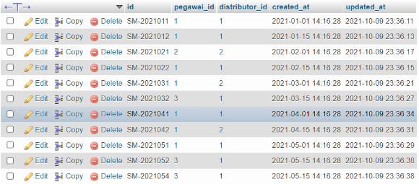

* Tabel Pengadaan Sesudah

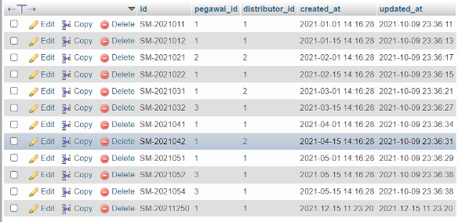

* Tabel Pengadaan detail sebelum

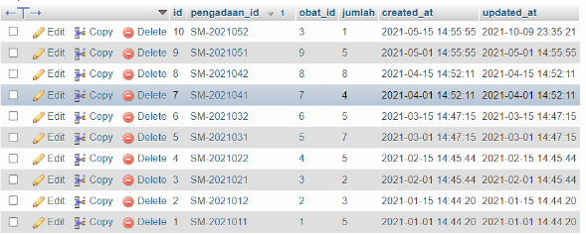

* Tabel Pendadaan detail sesudah

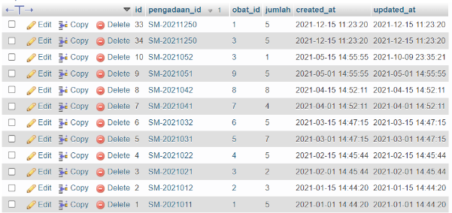

* Tabel Obat sebelum

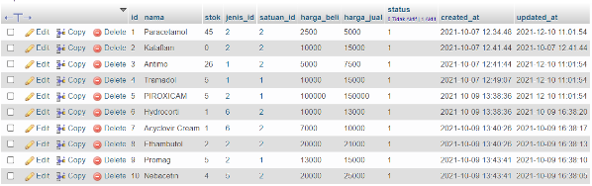

* Tabel obat sesudah

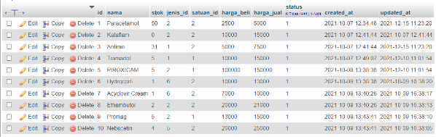

* Hasil query dari sintaks diatas

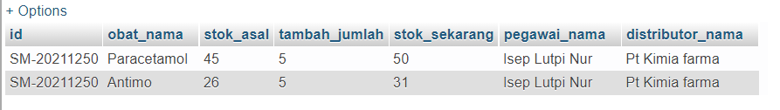

1. Transaksi Error/ Tidak normal
2. Sintaks

START TRANSACTION; -- Start

SET @pengadaan_id = 'SM-20211251';

SET @pegawai_id = 1; -- Isep Lutpi

SET @distributor_id = 1; -- Pt Kimia Farma

-- Header

CALL insertPengadaanHeader(@pengadaan_id, @pegawai_id, @distributor_id);

-- Body

SET @obat = 50; -- Obat tidak ada

SET @jumlah = 5;

CALL insertPengadaanBody(@pengadaan_id, @obat, @jumlah);

SET @obat = 3; -- Antimo

SET @jumlah = 5;

CALL insertPengadaanBody(@pengadaan_id, @obat, @jumlah);

-- View

CALL insertPengadaanView(@pengadaan_id);

COMMIT; -- End

1. Hasil

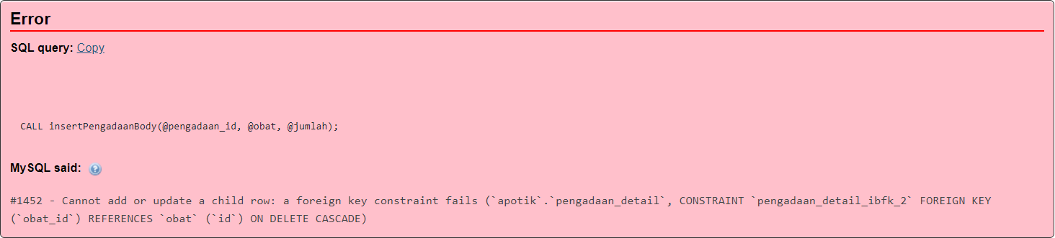

Tabel pengadaan, pengadaan detail dan obat tetap sama tidak ada perubahan

1. Contoh kasus transaksi dengan rollback
2. Transaksi Normal
3. Sintaks

SET @nama_jenis = 'Tes Tes';

SET @keterangan = 'Keterangan';

set @status = 1; -- 0 = tidak atif | 1 = aktif

CALL insertJenis(@nama_jenis, @keterangan, @status);

1. Hasil

* Tabel Jenis Sebelum

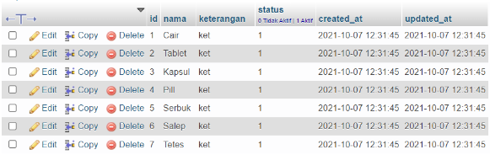

* Tabel Jenis Sesudah

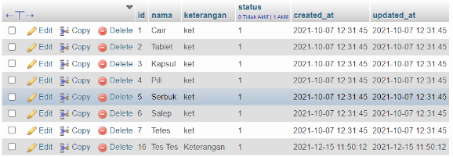

* Hasil Query

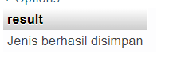

1. Transaksi Error/ Tidak Normal
2. Sintaks

  SET @nama_jenis = 'Cair'; -- Cair sudah ada

  SET @keterangan = 'Keterangan';

  set @status = 1; -- 0 = tidak atif | 1 = aktif

  CALL insertJenis(@nama_jenis, @keterangan, @status);

1. Hasil

Dalam query ini tidak ada perubahan dalam tabel jenis.

Hasil Query

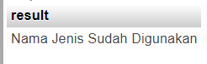

1. Coonth kasus transaksi dengan checkpoint
2. Sintaks

START TRANSACTION; -- Start

SET @penjualan_id = 'SK-2021216';

SET @pegawai_id = 1;

SET @pembeli_id = 1;

-- Header

CALL insertPenjualanHeader(@penjualan_id, @pegawai_id, @pembeli_id);

-- Body

SET @obat = 1; -- Paracetamol

SET @jumlah = 5;

CALL insertPenjualanBody(@penjualan_id, @obat, @jumlah);

SAVEPOINT Paracetamol;

SET @obat = 3; -- Antimo

SET @jumlah = 4;

CALL insertPenjualanBody(@penjualan_id, @obat, @jumlah);

ROLLBACK TO SAVEPOINT Paracetamol;

SET @obat = 4; -- Tramadol

SET @jumlah = 2;

CALL insertPenjualanBody(@penjualan_id, @obat, @jumlah);

-- View

CALL insertPenjualanView(@penjualan_id);

COMMIT; -- End

1. Hasil

* Tabel penjualan sebelum

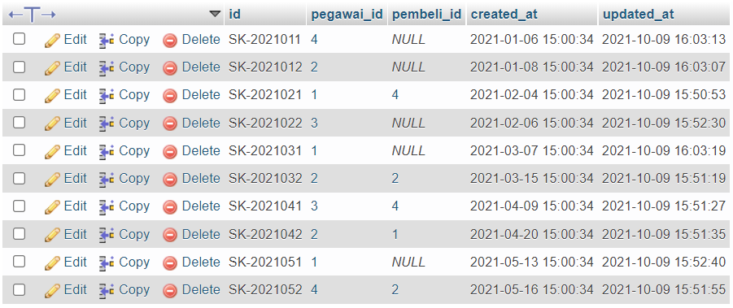

* Tabel Penjualan sesudah

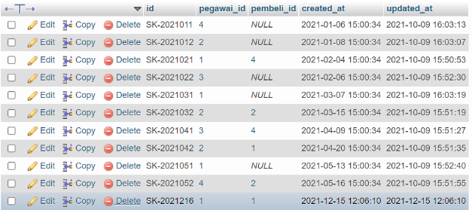

* Tabel Penjualan detail sebelum

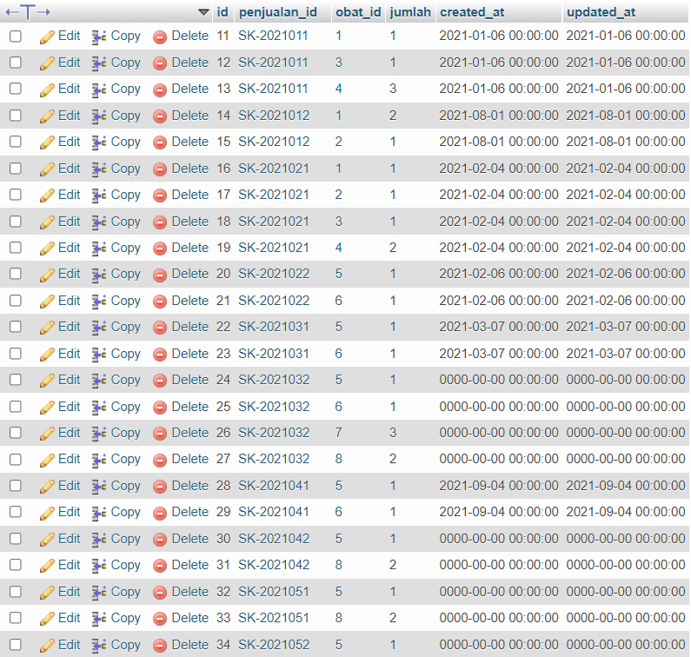

* Tabel Penjualan detail sesudah

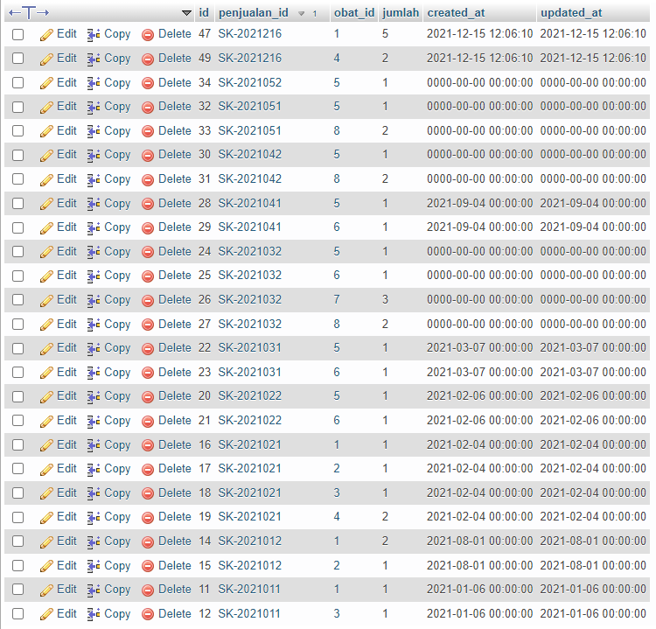

* Tabel Obat sebelum

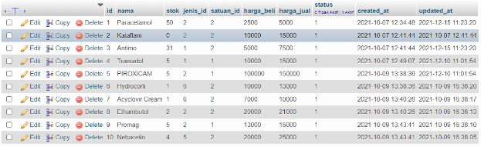

* Tabel Obat sesudah

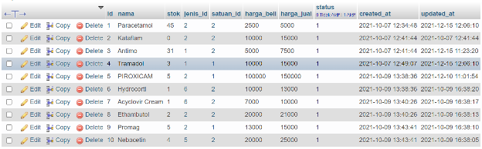

* Hasil query

